Preschool Class #2

7:00AM-8:00am | Educational Centres/ Free play  Art offered/Morning snack  Diapers as needed
8:00-10:00am | 8-9 – 8 children outside  9-10- 16 children outside  Children inside engaged in small groups/centers/snack
10:00-11:00am | Washroom/Hand washing/ Centers/ small group gatherings
11:00-11:15am | Hand Washing and prepare for lunch
11:15-12:00pm | Lunch
12:00-2:00pm | Rest Time  Children who do not sleep engage in quiet independent activities
2:00-2:30pm | Wake up/Washroom Routine/ Hand washing/Snack
2:30-3:30pm | Outdoor time
3:30-6:00pm | Educational Centres/Free Play  Art offered/ small group gatherings  Recall time/washroom as needed  Late snack offered
Inclement weather- gross motor in the classroom for 30 minutes/free play
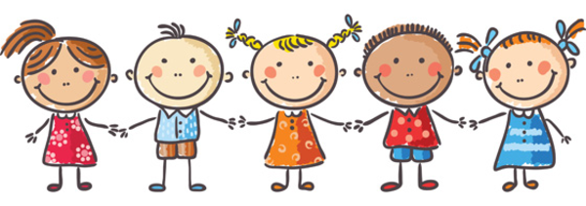

UPDATED May 2/18

