Toddler Room #2

7:00AM-10:00AM | Educational Centres/ Free play  Art offered/Morning snack/small group time  Diapers as needed
10:00am-11:00am | Outdoor Time
11:00AM-12:00PM | Hand washing routine / Diapers  And Lunch
12:00PM-2:00PM | Rest Time
2:00PM-2:45PM | Diaper/Hand washing routine  Afternoon snack
2:45PM-4:30pm | Centers/ small group time/art offered
4:30pm-5:30pm | Outdoor time
5:30PM-6:00PM | Educational Centres/Free Play  Art offered  Diaper change if needed/  Late snack offered
Inclement weather- gross motor in the classroom for 30 minutes/free play | *** PM outdoor time will be changed to 3:30-4:30 if both classes combined does not exceed 19 on the playground***
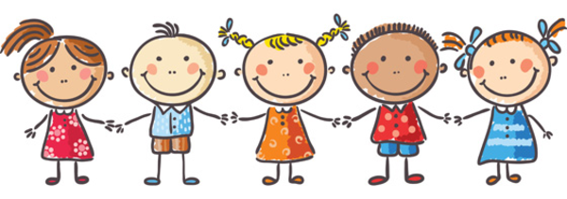

UPDATED May2/18

